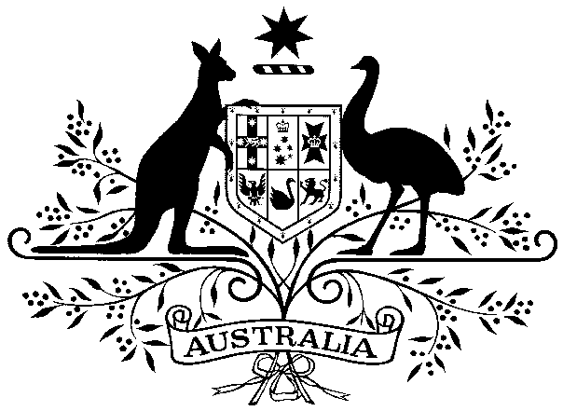

COMMUNICATIONS AND ENGAGEMENT DIRECTOR (Senior Adviser 2)

Office of Madeleine King MP
Federal Member for Brand
Minister for Resources and Minister for Northern Australia
The office is seeking applications for a full-time ongoing position of Communications and Engagement Director to join the Office of the Hon Madeleine King MP. The role will be based in the Commonwealth Parliamentary Office Perth, Western Australia or at Parliament House in Canberra, ACT.

Position Overview
The Office of Madeleine King MP is seeking an experienced person with a background in media, social media, communications and communications strategy. Leading a small team, the Communications and Engagement Director will oversee the development and implementation of strategic media and communications initiatives for the Minister across the Resources and Northern Australia portfolios.

Duties
- Lead the development and implementation of strategic communications and engagement plans aligned with Ministerial priorities.
- Oversee all media relations activities, including but not limited to press releases, media responses, and interview preparation.
- Develop and deliver impactful digital communications and content strategy, including social media governance and online engagement.
- Work with the Minister and her team, and across Government, to develop effective narratives and frames across the Minister’s responsibilities.
- Provide expert and timely advice on priority, complex and sensitive media, communications and strategic matters.
- Maintain effective relationships with the Prime Minister’s Office, other Ministerial Offices and the Australian Public Service on all priority, complex and sensitive issues.
- Establish and maintain effective relationships with the Press Gallery and other journalists in relation to the Minister’s announcements and policy agenda, and the agenda of the Government more broadly.
- Establish and maintain strong relationships with media and portfolio stakeholders as required.
- Monitor and advise on media and communication developments.
- Provide evidence based reporting to the Minister and staff on media, digital engagement, online trends and emerging issues.
- Lead a small team, as a senior staff member, in collaboration with the Chief of Staff and Deputy Chiefs of Staff.
- Regular interstate and Canberra travel will be required for this role, with irregular work hours, particularly during parliamentary sitting weeks.

The ideal applicant should possess the following skills and experience:
- Demonstrated experience in providing high-level advice on a wide range of communications, policy, administrative and political matters in a public, non-profit or private sector organisation.
- Highly developed communication and liaison skills, with the ability to effectively engaged and build productive relationships with Ministerial Offices, the Australian Public Service and key stakeholders.
- Significant experience in planning, developing, and implementing strategic communications and engagement strategies, including media, stakeholder, digital, and issues management initiatives.
- Demonstrated experience leading and working in teams to achieve outcomes in in a high-pressure environment. as part of a team.
- Demonstrated extensive knowledge of the political process and the Australian parliamentary and political system.
- Proven ability to work cooperatively to achieve whole of government strategic objectives.
- Demonstrated professional integrity and the ability to exercise discretion and maintain confidentiality.
- Demonstrated capacity for applying analytical and problem-solving skills in developing solutions for complex issues.
- Ability to rapidly acquire a sound knowledge of the structure and functions of the portfolio.
- Proven reliability in meeting deadlines and commitments especially in high pressure situations.

Employment conditions:
The position is offered under the Members of Parliament (Staff) Act 1984 and conditions are outlined in the Commonwealth Members of Parliament Staff Enterprise Agreement 2024-27 which include:

- A commencing salary between $156,510 and $205,808 will be negotiated depending on experience and relevant skills.

- An additional Personal Staff Allowance of up to $38,635 may be considered in recognition of, and as compensation for, reasonable additional hours of work.

- Relocation assistance, studies assistance and paid study leave may also be available (subject to eligibility requirements).

- An employer superannuation contribution of 15.4% will be payable.

Applicants should note the following:
- The successful applicant will be required to obtain and maintain an Australian Government security clearance (Negative Vetting Level 2) and comply with the Ministerial Staff Code of Conduct.

- The successful applicant will be required to comply with their obligations under the Behaviour Codes and Standards.

- An initial probationary period of three months will apply and may be subject to extension.

- The successful applicant may be required to undergo a National Police History Check.

- Staff may be subject to automatic cessation triggers in accordance with Section 14 of the MOP(S) Act.

How to apply
Applications should be forwarded to minister.king@resources.gov.au and include a resume with the contact details of two referees, and a cover letter (2 pages maximum) outlining your experience and skills.

Applications close on Wednesday, 23 September 2026

Contact officer: Laurence Coleman, Chief of Staff on minister.king@resources.gov.au or (02) 6277 7930.

Government staff represent the diverse Australian community they serve. Applications from Australians with diverse backgrounds and life experiences are encouraged.

